MLA0105- ARTIFICIAL INTELLIGENCE AND EXPERT SYSTEMS
1) In sliding puzzle, it consists of a 3x3 grid with eight numbered tiles and one empty space. The goal of the
puzzle is to rearrange the tiles from their initial, scrambled state to a goal state where the numbers are
ordered from 1 to 8, with the empty space in the bottom-right corner. Implement the same using python.
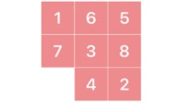

import heapq
# Goal state
GOAL_STATE = ((1, 2, 3),
(4, 5, 6),
(7, 8, 0))
# Possible moves: Up, Down, Left, Right
MOVES = [(-1, 0), (1, 0), (0, -1), (0, 1)]
# Manhattan distance heuristic
def manhattan_distance(state):
distance = 0
for i in range(3):
for j in range(3):
value = state[i][j]
if value != 0
target_x = (value - 1) // 3
target_y = (value - 1) % 3
distance += abs(target_x - i) + abs(target_y - j)
return distance

# Generate neighbors
def get_neighbors(state):
for i in range(3):
for j in range(3):
if state[i][j] == 0:
x, y = i, j
neighbors = []
for dx, dy in MOVES:
nx, ny = x + dx, y + dy
if 0 <= nx < 3 and 0 <= ny < 3:
new_state = [list(row) for row in state]
new_state[x][y], new_state[nx][ny] = new_state[nx][ny], new_state[x][y]
neighbors.append(tuple(tuple(row) for row in new_state))
return neighbors

# Solve puzzle using A* search
def solve_puzzle(start_state):
start = tuple(tuple(row) for row in start_state)
pq = [(manhattan_distance(start), 0, start)]
visited = set()

while pq:
_, cost, state = heapq.heappop(pq)
if state in visited:
continue
visited.add(state)
if state == GOAL_STATE:
return state
for neighbor in get_neighbors(state):
heapq.heappush(pq, (cost + 1 + manhattan_distance(neighbor), cost + 1, neighbor))
return None

# Print the puzzle state
def print_state(state):
for row in state:
print(' '.join(str(x) if x != 0 else '_' for x in row))
print()

# Take input from user
print("Enter the initial 8-puzzle state (0 for empty tile) row by row, numbers separated by spaces:")
start_state = [list(map(int, input(f"Row {i+1}: ").split())) for i in range(3)]

print("\nInitial State:")
print_state(start_state)

final_state = solve_puzzle(start_state)
if final_state:
print("Final Solved State:")
print_state(final_state)
else:
print("No solution found.")
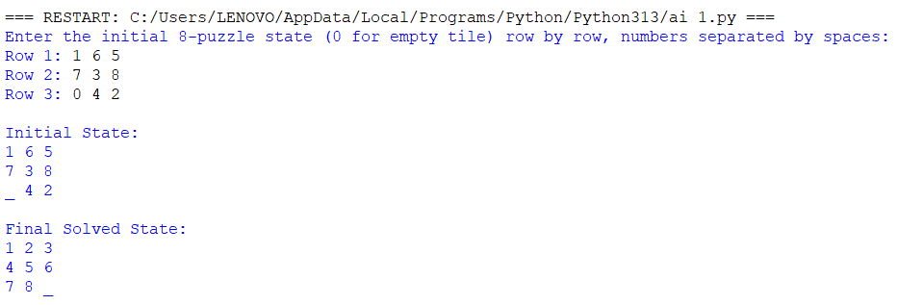

2) The Towers of Hanoi problem involves three pegs (A, B, C) and a number of disks of different sizes that
can slide onto any peg. The puzzle starts with all the disks stacked on one peg in order of decreasing size,
with the largest at the bottom.
The objective of the problem is to move the entire stack to another peg, following these rules:
a) Only one disk can be moved at a time.
b) Each move consists of taking the upper disk from one of the stacks and placing it on top of another
stack.
c) No disk may be placed on top of a smaller disk.
Implement the above Towers of Hanoi problem using Python.
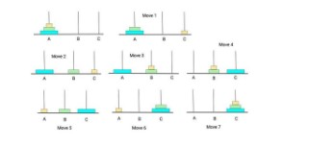
def towers_of_hanoi(n, source, auxiliary, target):
if n == 1:
print(f"Move disk 1 from {source} to {target}")
return
# Move n-1 disks from source to auxiliary peg
towers_of_hanoi(n - 1, source, target, auxiliary)

# Move the remaining disk from source to target
print(f"Move disk {n} from {source} to {target}")

# Move the n-1 disks from auxiliary to target peg
towers_of_hanoi(n - 1, auxiliary, source, target)

# Main Program
num_disks = int(input("Enter the number of disks: "))
print(f"\nSteps to solve Tower of Hanoi with {num_disks} disks:\n")
towers_of_hanoi(num_disks, 'A', 'B', 'C')

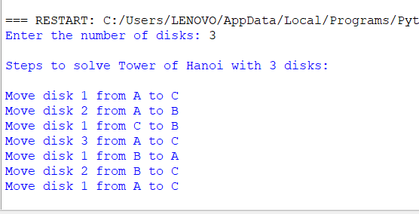

3) Implement a Python program to perform Breadth-First Search (BFS) on a graph. The program should:
• Represent the graph using an adjacency list.
• Start the traversal from a given source node.
• Print the order in which the nodes are visited
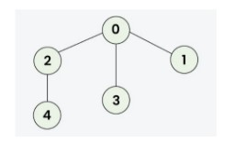
#BFS
from collections import deque

def bfs(graph, start):
visited = []
queue = deque([start])

while queue:
node = queue.popleft()
if node not in visited:
print(node, end=" ")
visited.append(node)
for neighbor in graph.get(node, []):
if neighbor not in visited:
queue.append(neighbor)

# ---- MAIN PROGRAM ----
graph = {}

n = int(input("Enter the number of levels in the graph: "))

print("\nEnter each node and its neighbors.")
print("Example: For node A with neighbors B and C, enter: A B C")
print(" For node 1 with neighbors 2 and 3, enter: 1 2 3\n")

for _ in range(n):
data = input("Enter node and its neighbors: ").split()
node = data[0]
# Convert to int if possible
try:
node = int(node)
except ValueError:
pass

neighbors = []
for val in data[1:]:
try:
neighbors.append(int(val))
except ValueError:
neighbors.append(val)

graph[node] = neighbors

# Display the graph
print("\nGraph (Adjacency List):")
for node, neighbors in graph.items():
print(f"{node} -> {neighbors}")

# BFS Traversal
start = input("\nEnter the starting node: ")
try:
start = int(start)
except ValueError:
pass

if start not in graph:
print("\nInvalid starting node!")
else:
print(f"\nBreadth-First Search traversal starting from node {start}:")
bfs(graph, start)

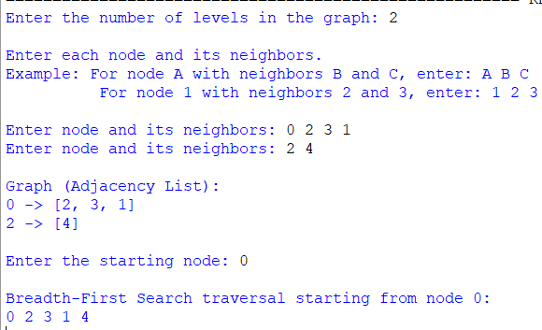
4) The Monkey and Banana problem is a classic artificial intelligence problem where a monkey needs to
navigate through a room to reach a bunch of bananas hanging from the ceiling. The monkey has to move
a box to stand on it to reach the bananas. Implement the above scenario using python.

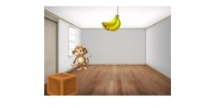
initial_state = {
'monkey': 'A',
'box': 'B',
'monkey_on_box': False,
'has_banana': False
}

goal_state = {
'has_banana': True
}

banana_position = 'C' # Bananas are hanging at position C

def display_state(state):
print(f"Monkey at: {state['monkey']}, Box at: {state['box']}, "
f"On Box: {state['monkey_on_box']}, Has Banana: {state['has_banana']}")

def move(state, position):
state['monkey'] = position
print(f"Monkey moves to {position}")
return state

def push_box(state, position):
if state['monkey'] == state['box']:
state['monkey'] = position
state['box'] = position
print(f"Monkey pushes the box to {position}")
else:
print("Monkey needs to be at the box to push it!")
return state

def climb_box(state):
if state['monkey'] == state['box']:
state['monkey_on_box'] = True
print("Monkey climbs on the box")
else:
print("Monkey must be at the box to climb it!")
return state

def grab_banana(state):
if state['monkey_on_box'] and state['box'] == banana_position:
state['has_banana'] = True
print("Monkey grabs the banana! 🍌")
else:
print("Monkey cannot reach the banana yet.")
return state

# --- Simulation ---
print("Initial State:")
display_state(initial_state)
print("\nActions:")

# Step 1: Move to the box
move(initial_state, 'B')

# Step 2: Push box to bananas
push_box(initial_state, 'C')

# Step 3: Climb onto the box
climb_box(initial_state)

# Step 4: Grab the bananas
grab_banana(initial_state)

# --- Final State ---
print("\nFinal State:")
display_state(initial_state)

if initial_state['has_banana']:
print("\n✅ Goal achieved! Monkey got the bananas!")
else:
print("\n❌ Goal not achieved.")

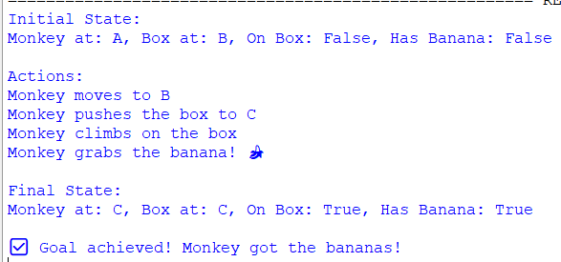
5) Write the python program to place eight queens on an 8 x 8 chessboard in such a way that no two queens
threaten each other. In other words, no two queens can share the same row, column, or diagonal. Use
backtracking to explore different possibilities and ensures that no two queens threaten each other.

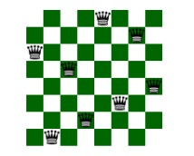
# 8 Queens Problem using Backtracking

N = 8 # Chessboard size (8x8)

def print_solution(board):
"""Display the chessboard with queens placed safely."""
for row in board:
print(" ".join("Q" if x == 1 else "." for x in row))
print("\n")

def is_safe(board, row, col):
"""Check if a queen can be safely placed at board[row][col]."""

# Check this column on upper rows
for i in range(row):
if board[i][col] == 1:
return False

# Check upper left diagonal
for i, j in zip(range(row-1, -1, -1), range(col-1, -1, -1)):
if board[i][j] == 1:
return False

# Check upper right diagonal
for i, j in zip(range(row-1, -1, -1), range(col+1, N)):
if board[i][j] == 1:
return False

return True

def solve_nqueens(board, row):
"""Use backtracking to solve the N Queens problem."""
# Base case: If all queens are placed
if row >= N:
print_solution(board)
return True

success = False
for col in range(N):
if is_safe(board, row, col):
board[row][col] = 1 # Place the queen
success = solve_nqueens(board, row + 1) or success
board[row][col] = 0 # Backtrack (remove the queen)

return success

def solve():
"""Initialize board and trigger solver."""
board = [[0] * N for _ in range(N)]
if not solve_nqueens(board, 0):
print("No solution exists.")
else:
print("All possible solutions found.")

# Run the solver
solve()

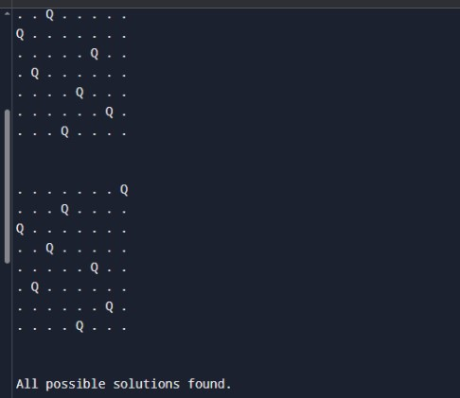

6) Implement a Python program to perform Depth-First Search (DFS) on a graph. The program should:
• Represent the graph using an adjacency list.
• Traverse the graph starting from a given source node.
• Print the order in which the nodes are visited.
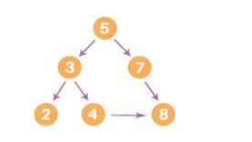
# Depth-First Search (DFS) using adjacency list
# Depth-First Search (DFS) using adjacency list

def dfs(graph, start, visited=None):
if visited is None:
visited = set()

# Mark the current node as visited
visited.add(start)
print(start, end=" ")

# Visit all adjacent nodes
for neighbor in graph[start]:
if neighbor not in visited:
dfs(graph, neighbor, visited)

# Example graph (Adjacency List)
graph = {
5: [3, 7],
3: [2, 4],
7: [8],
2: [],
4: [],
8: []
}
# Starting node
start_node = 5

print("DFS Traversal:")
dfs(graph, start_node)

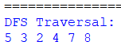

7. Solve the given problem using python. Consider a Water Jug problem: You are given two jugs, a 4-gallon
one and a 3-gallon one. Neither has any measuring marker on it. There is a pump that can be used to fill
the jugs with water. How can you get exactly 2 gallons of water into the 4-gallon jug? Explicit
Assumptions: A jug can be filled from the pump, water can be poured out of a jug onto the ground, water
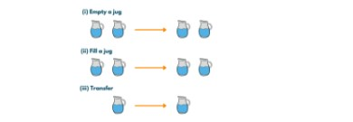
from collections import deque
def water_jug_problem():
jugA, jugB = 4, 3
visited = set()
queue = deque([(0, 0, [])])

while queue:
a, b, path = queue.popleft()
if (a, b) in visited:
continue
visited.add((a, b))
path = path + [(a, b)]
if a == 2:
print("Steps to get exactly 2 gallons in the 4-gallon jug:\n")
for step in path:
print(f"Jug A: {step[0]} gallons, Jug B: {step[1]} gallons")
return

next_states = []
next_states.append((jugA, b))
next_states.append((a, jugB))
next_states.append((0, b))
next_states.append((a, 0))
pour = min(a, jugB - b)
next_states.append((a - pour, b + pour))
pour = min(b, jugA - a)
next_states.append((a + pour, b - pour))

# Add next states to queue
for state in next_states:
if state not in visited:
queue.append((state[0], state[1], path))

print("No solution found.")

water_jug_problem()

